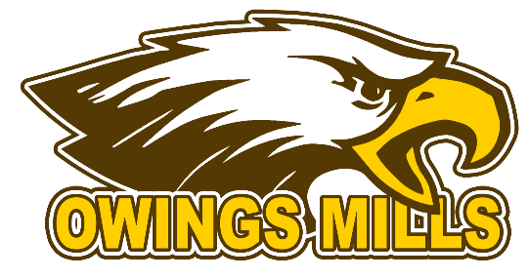
2017 School Store Apparel Order Form
Please make all checks payable to Owings Mills High School
Orders should be returned to Mr. or Mrs. Blumenauer, or
the school store no later than September 29th Orders
submitted after that date will not be completed.

Item | Size | Quantity |  | Item | Size | Quantity
Sweatpants- $20  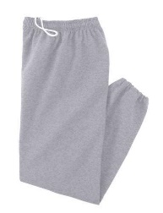 |  |  |  | Polo Mens/Womens Cut  Cotton- $20  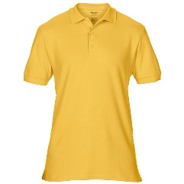 |  | Gold  White  Grey
Hoodie- $20  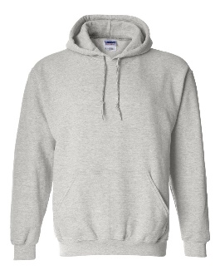 |  |  |  | Polo  Dri-Fit- $30  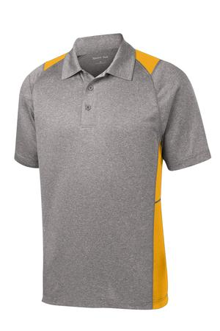
Pullover Jacket- $35  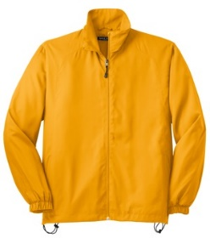 |  |  |  | Tie Dye Shirt $20  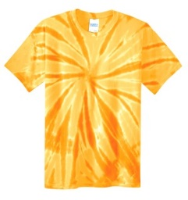
Wind Jacket - $35  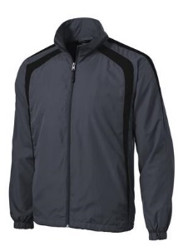 |  |  |  | 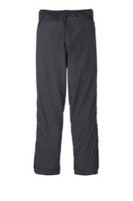  Wind pants (match grey jacket) $30  with pockets and open bottom
Shorts- Mens style w/pockets $20  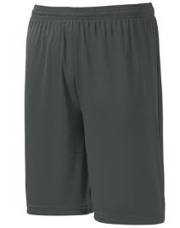 |  |  |  | Socks $8  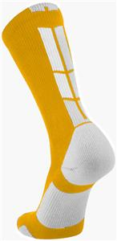
Womens Shorts $20  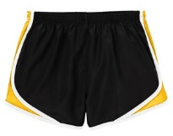 |  |  |  | Cotton T-Shirt $10  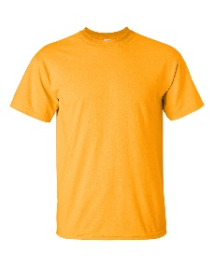 |  | Grey  Gold  White
Womens $20 Sleeveless T-shirt  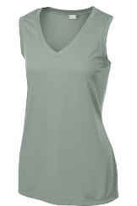 |  |  |  | Short Sleeve Dri-Fit $20  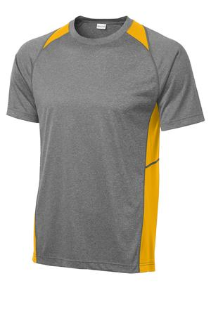
Long Sleeve Pocket Tee $20  EAGLES IN GOLD ACROSS BACK SHOULDERS  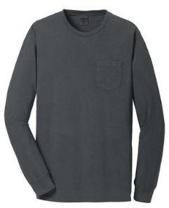 |  |  |  | Long Sleeve Dri-Fit $25  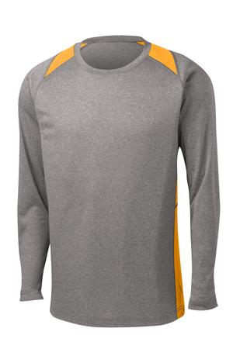

Total Payment: ____________________ Received by: ______________________
All orders must be turned in by September 29th with payment in full. Checks can be made out to Owings Mills High School. Any questions please email Tom Blumenauer tblumenauer@bcps.org

