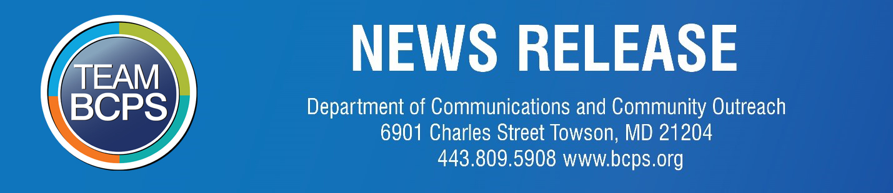

FOR RELEASE: Oct. 27, 2020 CONTACT: Dept. of Communications/Community Outreach, 443.809.5908
BCPS press releases are available online

BCPS shares its fall re-engagement plan for high school athletics
Voluntary conditioning and Skill Development for winter sports scheduled to begin Nov. 16; play to begin on Jan. 4

TOWSON, MD. – Baltimore County Public Schools has announced its fall re-engagement plan for high school athletics.

According to the plan, student-athletes will return to their school campuses to participate in voluntary conditioning and skill development session. The tentative schedule is that the small group conditioning and skill development sessions (of 20 students or fewer) will take place:

For winter sports Nov. 16 – Dec. 4
For fall sports Dec. 7 – Dec. 30
For spring sports Jan. 4 – Jan. 22

BCPS noted that these dates are subject to change, and activities are subject to cancellation at any time.

Additionally, on Oct, 26, the Maryland State Board of Education voted to approve the MPSSAA Proposal to accelerate competitive athletics beginning on December 7. In accordance with this direction, BCPS will also begin competitive sports in the following manner:

Winter season
First practice – Dec. 7
First play date – Jan. 4
Last play date – Feb. 13

Fall season
First practice – Feb. 13
First play date – Mar. 5
Last play date – Apr. 17

Spring season
First practice – Apr. 17
First play date – May 7
Last play date – Jun. 19

“We appreciate the important and unique role that athletics play in connecting students to their schools, promoting physical and mental health, developing students’ collaborative and leadership skills, and more,” said BCPS Superintendent Dr. Darryl L. Williams. “We have worked closely with our athletics and health services staff and with the Baltimore County Department of Health in developing this opportunity to bring student-athletes back to school campuses for conditioning and skill development activities.”

The conditioning/skill based development sessions will be open to all interested high school students. No tryouts will be involved. To participate, students will be required to register, complete pre-participation physicals, sign parent/student participation acknowledgement statements. Students will be encouraged, but not required, to receive flu shots.

In addition, participation will require that students adhere to several requirements such as wearing face coverings, practicing social distancing, bringing their own water bottles and hand sanitizer to each practice, and demonstrating good hygiene and behavior. Students who fail to observe these requirements may be removed from the program and not permitted to return.

The availability of transportation will be announced soon.

The full plan, available online, offers more detailed information about accommodations for students with special needs, inclement weather, workout times, sanitization of equipment, and other procedures to protect students and staff from COVID-19.

In addition to the in-person voluntary conditioning and skill development sessions, BCPS will continue to offer virtual coaching and conditioning to high school student-athletes through the first semester, which ends Jan. 29, 2021.

# # #

Baltimore County Public Schools, the nation’s 25th largest school system, is focused on raising the bar and closing gaps to prepare our students for the future. Thanks to innovative and talented leaders, teachers, staff, and students, BCPS celebrates many honors.

